**Brain Tumour Extraction and detection from MRI**

**Images Using Machine Learning and MATLAB**

IMAGE PROCESSING - J COMPONENT

SUBMITTED BY :

Rajat Bhatia-16BCE0513

Sarthak Singhal-16BCE0387

Ipsita Bajpai-15BCE0061

SUBMITTED TO :

Prof. ANISHA M. LAL



**LIST OF CONTENTS:**

**ABSTRACT**……………………………………………………………………………3

**PROBLEM STATEMENT**……………………………………………………………3

**INTRODUCTION**……………………………………………………………………..4

**METHODOLOLOGY**…………………………………………………………………5

**IMPLEMENTATION**………………………………………………………………….9

**APPENDIX-1**…………………………………………………………………………...9

**APPENDIX-2**…………………………………………………………………………...12

**RESULT**………………………………………………………………………………...15

**SCOPE**…………………………………………………………………………………..15

**REFRENCES**…………………………………………………………………………...15

**ABSTRACT:**

The field of medicine is always a necessity and development in them is basic necessity for betterment of human kind

Medical image processing is the most challenging and emerging field now a days. Processing of MRI images is one of the part of this field. Identification Tumour are rising problem as there is rise in people being affected by tumour this rise is caused by lot of factors from habits to pollution . Locating a tumour as always been problem as that requires a lot of experience of human anatomy which is requires a lot of time.

This project describes the proposed strategy to detect & extraction of brain tumour from patients.

MRI scan images of the brain. This method incorporates with, segmentation and morphological operations which are the basic concepts of image processing. Detection and extraction of tumour from MRI scan images of the brain is done by using MATLAB software. We first concentrate on creating a program which requires a small processing time for result. Over the last decade numerous methods have already been proposed.

In recent years, researchers have proposed a lot of approaches for this goal, which fall into two categories. One category is supervised classification, including support vector machine (SVM) and k-nearest neighbours (k-NN). The other category is unsupervised classification, including self-organization feature map (SOFM)

and fuzzy c-means.

**PROBLEM STATEMENT:**

We have to detect the brain tumours in MRI scanned images and tell weather the tumour is benign or malignant by using SVM machine learning algorithm, which will help the doctors in the brain surgeries and other tests.

**INTRODUCTION:**

Tumour is defined as the abnormal growth of the tissues. Brain tumour is an abnormal mass of tissue in which cells grow and multiply uncontrollably, seemingly unchecked by the mechanisms that control normal cells. Brain tumours can be primary or metastatic, and either malignant or benign. A metastatic brain tumour is a cancer that has spread from elsewhere in the body to the brain

Epilepsy is a brain disorder in which clusters of nerve cells, or neurons, in the brain sometimes signal abnormally. Neurons normally generate electrochemical impulses that act on other neurons, glands, and muscles to produce human thoughts, feelings, and actions. In epilepsy, the normal pattern of neuronal activity becomes disturbed, causing strange sensations, emotions, and behaviour or sometimes convulsions, muscle spasms, and loss of consciousness.

Magnetic Resonance Imaging (MRI) is an advanced medical imaging technique used to produce high quality images of the parts contained in the human body MRI imaging is often used when treating brain tumours, ankle, and foot. From these high-resolution images, we can derive detailed anatomical information to examine human brain development and discover abnormalities. Nowadays there are several methodology for classifying MR images, which are fuzzy methods, neural networks, atlas methods, knowledge based techniques, shape methods, variation segmentation. MRI consists of T1 weighted, T2 weighted and PD (proton density) weighted images and are processed by a system which integrates fuzzy based technique with multispectral analysis [2].

Pre-processing of MRI images is the primary step in image analysis which perform image enhancement and noise-reduction techniques which are used to enhance the image quality, then some morphological operations are applied to detect the tumour in the image. The morphological operations are basically applied on some assumptions about the size and shape of the tumour and in the end the tumour is mapped onto the original gray scale image with 255 intensity to make visible the tumour in the image. The algorithm has been tried on a number of patients MRI data of brain tumour images in.

In recent years, researchers have proposed a lot of approaches for this goal, which fall into two categories. We would be using supervised learning method as it better than unsupervised classifier in terms of classification accuracy.

Among supervised classification methods, the SVMs are state-of-the-art classification methods based on machine learning theory. Compared with other methods such as artificial neural network, decision tree, and Bayesian network, SVMs have significant advantages of high accuracy, elegant mathematical tractability, and direct geometric interpretation. Besides, it does not need a large number of training samples to avoid overfitting .

**METHODOLOGY:**

The algorithm has two stages, first is pre-processing of given MRI image and after that segmentation and then perform morphological operations. Steps of algorithm are as following:-

1. Give MRI image of brain as input.
2. Convert it to gray scale image.
3. Compute threshold segmentation.
4. Pre-processing (including feature extraction and feature reduction).
5. Training the machine using SVM.
6. Submit the new output MRI images to the SVM.
7. Finally output will be a tumour region stating it is benign or malignant.

All above steps are explained here in detail.

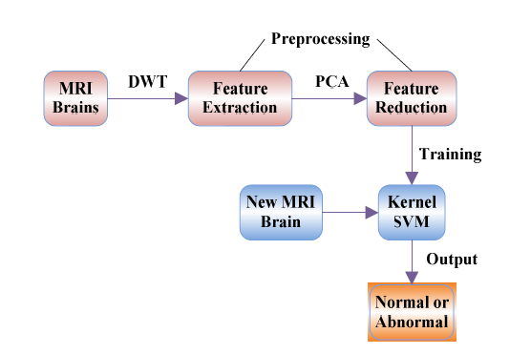

*1. Grayscale Imaging*

MRI images are magnetic resonance images which can be acquired on computer when a patient is scanned by MRI machine. We can acquire MRI images of the part of the body which is under test or desired. Generally when we see MRI images on computer they looks like black and white images. In analog practice, gray scale imaging is sometimes called "black and white," but technically this is a misnomer. In true black and white, also known as halftone, the only possible shades are pure black and pure white. The illusion of gray shading in a halftone image is obtained by rendering the image as a grid of black dots on a white background (or vice-versa), with the sizes of the individual dots determining the apparent lightness of the gray in their vicinity. The halftone technique is commonly used for printing photographs in newspapers and as MRI image is taken on computer then In the case of transmitted light (for example, the image on a computer display), the brightness levels of the red (R), green

(G) and blue (B) components are each represented as a number from decimal 0 to 255, or binary 00000000 to 11111111. For every pixel in a red-green-blue ( RGB ) grayscale image, R = G = B. The lightness of the gray is directly proportional to the number representing the brightness levels of the primary colours. Black is represented by R = G = B = 0 or R = G = B = 00000000, and white is represented by R = G = B = 255 or R = G = B = 11111111. Because there are 8 bit s in the binary representation of the gray level, this imaging method is called 8-bit grayscale

Grayscale is a range of shades of gray without apparent colour. The darkest possible shade is black, which is the total absence of transmitted or reflected light. The lightest possible shade is white, the total transmission or reflection of light at all visible wavelengths. So because of the above reasons first we convert our MRI image to be pre-processed in grayscale image

*2. Threshold Segmentation*

The simplest method of image segmentation is called the thresholding method. This method is based on a clip-level (or a threshold value) to turn a gray-scale image into a binary image.

The key of this method is to select the threshold value (or values when multiple-levels are selected).

Image into multiple segments (sets of pixels, also known as super pixels). The goal of segmentation is to simplify and/or change the representation of an image into something that is more meaningful and easier to analyse.[1] Image segmentation is typically used to locate objects and boundaries (lines, curves, etc.) in images. More precisely, image segmentation is the process of assigning a label to every pixel in an image such that pixels with the same label share certain visual characteristics.

Each of the pixels in a region are similar with respect to some characteristic or computed property, such as colour, intensity, or texture. Adjacent regions are significantly different with respect to the same characteristic(s).[1] When applied to a stack of images, typical in Medical imaging, the resulting contours after image segmentation can be used to create 3D reconstructions with the help of interpolation algorithms like Marching cubes.

*3. Feature Extraction*

The most conventional tool of signal analysis is Fourier transform (FT), which breaks down a time domain signal into constituent sinusoids of different frequencies, thus, transforming the signal from time domain to frequency domain. However, FT has a serious drawback as discarding the time information of the signal. For example, analyst can not tell when a particular event took place from a Fourier spectrum. Thus, the quality of the classification decreases as time information is lost. Gabor adapted the FT to analyze only a small section of the signal at a time. The technique is called windowing or short time Fourier transform (STFT). It adds a window of particular shape to the signal. STFT can be regarded as a compromise between the time information and frequency information. It provides some information about both time and frequency domain. However, the precision of the information is limited by the size of the window.

*4. Feature Reduction*

Excessive features increase computation times and storage memory. Furthermore, they sometimes make classification more complicated, which is called the curse of dimensionality. It is required to reduce the number of features. PCA is an efficient tool to reduce the dimension of a data set consisting of a large number of interrelated variables while retaining most of the variations. It is achieved by transforming the data set to a new set of ordered variables according to their variances or importance. This technique has three effects: it orthogonalizes the components of the input vectors so that uncorrelated with each other, it orders the resulting orthogonal components so that those with the largest variation come first, and eliminates those components contributing the least to the variation in the data set. It should be noted that the input vectors be normalized to have zero mean and unity variance before performing PCA. The

normalization is a standard procedure.

*5. Kernel SVM*

The introduction of support vector machine (SVM) is a landmark in the field of machine learning. The advantages of SVMs include high accuracy, elegant mathematical tractability, and direct geometric

interpretation. Recently, multiple improved SVMs have grown rapidly, among which the kernel SVMs are the most popular and effective. Kernel SVMs have the following advantages: (1) work

very well in practice and have been remarkably successful in such diverse fields as natural language categorization, bioinformatics and computer vision; (2) have few tunable parameters; and (3) training

often involves convex quadratic optimization. Hence, solutions are global and usually unique, thus avoiding the convergence to local minima exhibited by other statistical learning systems, such as neural

networks.

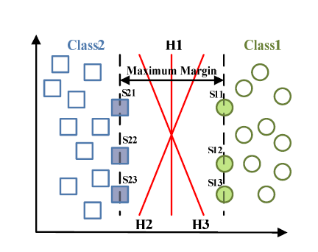 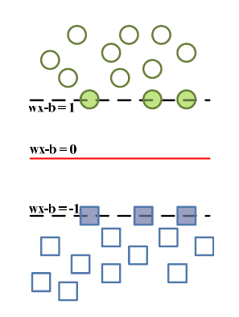

Figure. The geometric interpolation Figure. The concept of parallel hyperplanes.

of linear SVMs (H denotes for the

hyperplane, S denotes for the support

vector).

*6 – Principles of kernel SVM*

Given a p-dimensional N-size training dataset of the form

f(xn; yn)jxn 2 Rp; yn 2 f¡1; +1gg ; n = 1; : : : ;N

where yn is either -1 or 1 corresponds to the class 1 or 2. Each xn is a p-dimensional vector. The maximum-margin hyperplane which divides class 1 from class 2 is the support vector machine we want. Considering that any hyperplane can be written in the form of

w . x - b = 0

where . denotes the dot product and W the normal vector to the hyperplane. We want to choose the W and b to maximize the margin between the two parallel hyperplanes as large as possible while still separating the data. So we define the two parallel hyperplanes by the equations as

w .x - b = +-1

Therefore, the task can be transformed to an optimization problem, i.e., we want to maximize the distance between the two parallel hyperplanes, subject to prevent data falling into the margin.

Using simple mathematical knowledge, the problem can be formulated as

Min || w||

In practical situations the ||w|| is usually be replace by

Min 1/2 (||w||)^2

Table 1. Three common Kernels (HPOL, IPOL, and GRB) with their formula and parameters.

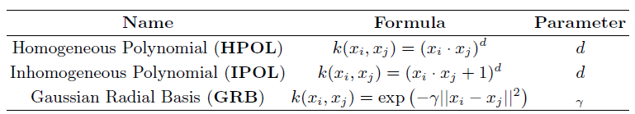

*6. Database*

The datasets consists of T2-weighted MR brain images in axial plane and 256*256 in-plane resolution, which were downloaded from the website of Harvard Medical School (URL:

http://med.harvard.edu/AANLIB/), OASIS dataset (URL: http://www.oasis-brains.org/), and ADNI dataset (URL: http://adni.loni.ucla.edu/). We choose T2 model since T2 images are of higher contrast and clearer vision compared to T1 and PET modalities. We randomly selected 20 images for each type of brain. Since there are one type of normal brain and seven types of abnormal brain in the dataset, 160 images are selected consisting of 20 normal and 140 abnormal brain images.

*7. Feature extraction and reduction*

The required features are extracted to be used as parameters in learning of the machine. The number of extracted features was reduced from 65536 to 1024. However, it is still too large for calculation. Thus, PCA is used to further reduce the dimensions of features to a higher degree. The variances versus the number of principle components from 1 to 20 are listed in Table 3. It shows that only 19 principle components (bold font in table), which are only 1.86% of the original features, could preserve 95.4% of total variance.

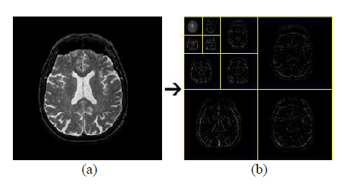

Figure. The procedures of 3-level 2D DWT: (a) normal brain MRI;

(b) level-3 wavelet coefficients.

**IMPLEMENTATION:**

**SAMPLE SNAPSHOTS(Appendix-1):**

**SAMPLE A**

**Benign**

|  |  |
| --- | --- |
|  |  |
|  |  |

**SAMPLE B**

**Malignant**

|  |  |
| --- | --- |
|  |  |
|  |  |

**SAMPLE C**

**Benign**

|  |  |
| --- | --- |
|  |  |
|  |  |

**SAMPLE D**

**Malignant**

|  |  |
| --- | --- |
|  |  |
|  |  |

**MATLAB CODE(Appendix-2):**

[filename,pathname] = uigetfile({'*.*';'*.bmp';'*.tif';'*.gif';'*.png'},'Pick an Image File');

I = imread([pathname,filename]);

figure, imshow(I); title('Brain MRI Image');

I = imresize(I,[200,200]);

gray = rgb2gray(I);

img = im2bw(I,0.6);

figure, imshow(img);title('Thresholded Image');

cform = makecform('srgb2lab');

lab_he = applycform(I,cform);

ab = double(lab_he(:,:,2:3));

nrows = size(ab,1);

ncols = size(ab,2);

ab = reshape(ab,nrows*ncols,2);

nColors = 1;

[cluster_idx cluster_center] = kmeans(ab,nColors,'distance','sqEuclidean', ...

'Replicates',1);

pixel_labels = reshape(cluster_idx,nrows,ncols);

segmented_images = cell(1,3);

rgb_label = repmat(pixel_labels,[1,1,3]);

for k = 1:nColors

colors = I;

colors(rgb_label ~= k) = 0;

segmented_images{k} = colors;

end

figure, imshow(segmented_images{1});title('Objects in Cluster 1');

seg_img = im2bw(segmented_images{1});

figure, imshow(seg_img);title('Segmented Tumor');

x = double(seg_img);

m = size(seg_img,1);

n = size(seg_img,2);

signal1 = seg_img(:,:);

[cA1,cH1,cV1,cD1] = dwt2(signal1,'db4');

[cA2,cH2,cV2,cD2] = dwt2(cA1,'db4');

[cA3,cH3,cV3,cD3] = dwt2(cA2,'db4');

DWT_feat = [cA3,cH3,cV3,cD3];

G = pca(DWT_feat);

whos DWT_feat

whos G

g = graycomatrix(G);

stats = graycoprops(g,'Contrast Correlation Energy Homogeneity');

Contrast = stats.Contrast;

Correlation = stats.Correlation;

Energy = stats.Energy;

Homogeneity = stats.Homogeneity;

Mean = mean2(G);

Standard_Deviation = std2(G);

Entropy = entropy(G);

RMS = mean2(rms(G));

Variance = mean2(var(double(G)));

a = sum(double(G(:)));

Smoothness = 1-(1/(1+a));

Kurtosis = kurtosis(double(G(:)));

Skewness = skewness(double(G(:)));

m = size(G,1);

n = size(G,2);

in_diff = 0;

for i = 1:m

for j = 1:n

temp = G(i,j)./(1+(i-j).^2);

in_diff = in_diff+temp;

end

end

IDM = double(in_diff);

feat = [Contrast,Correlation,Energy,Homogeneity, Mean, Standard_Deviation, Entropy, RMS, Variance, Smoothness, Kurtosis, Skewness, IDM];

load Trainset.mat

xdata = meas;

group = label;

svmStruct1 = svmtrain(xdata,group,'kernel_function', 'linear');

species = svmclassify(svmStruct1,feat,'showplot',false)

data1 = [meas(:,1), meas(:,2)];

newfeat = [feat(:,1),feat(:,2)];

svmStruct1_new = svmtrain(data1,group,'kernel_function', 'linear','showplot',false);

species_Linear_new = svmclassify(svmStruct1_new,newfeat,'showplot',false);

%%

load Trainset.mat

data = meas;

groups = ismember(label,'BENIGN ');

groups = ismember(label,'MALIGNANT');

[train,test] = crossvalind('HoldOut',groups);

cp = classperf(groups);

svmStruct = svmtrain(data(train,:),groups(train),'showplot',false,'kernel_function','linear');

classes = svmclassify(svmStruct,data(test,:),'showplot',false);

classperf(cp,classes,test);

svmStruct_RBF = svmtrain(data(train,:),groups(train),'boxconstraint',Inf,'showplot',false,'kernel_function','rbf');

classes2 = svmclassify(svmStruct_RBF,data(test,:),'showplot',false);

classperf(cp,classes2,test);

svmStruct_Poly = svmtrain(data(train,:),groups(train),'Polyorder',2,'Kernel_Function','polynomial');

classes3 = svmclassify(svmStruct_Poly,data(test,:),'showplot',false);

classperf(cp,classes3,test);

load Normalized_Features.mat

xdata = norm_feat;

group = norm_label;

indicies = crossvalind('Kfold',label,5);

cp = classperf(label);

for i = 1:length(label)

test = (indicies==i);train = ~ test;

svmStruct = svmtrain(xdata(train,:),group(train),'boxconstraint',Inf,'showplot',false,'kernel_function','rbf');

classes = svmclassify(svmStruct,xdata(test,:),'showplot',false);

classperf(cp,classes,test);

end

**RESULT**

From the results we can intervene that these process can be used to identify the location of tumour from an mri.as we can see the processing time of code from MRI image to image containing tumour is very less we can use this application in real time system which will very helpful in field on medicine

**SCOPE**

From this processed image we can create a database and use it for training an artificial neural network or deep learning algorithm which can identify even more details of tumour such as whether it is malignant of Benign .this can change the future of identification tumour. This scope will be revolution in field of medical science.

**REFERENCES:**

[1]W. Gonzalez, “Digital Image Processing”, 2nd ed. Prentice Hall, Year ofPublication 2008, Page no 378.

[2] S. Murugavalli, V. Rajamani, “A high speed parallel fuzzy c-meanalgorithm for brain tumour segmentation”,” BIME Journal”, Vol. no:

06, Issue (1), Dec., 2006

[3] Mohamed Lamine Toure, “Advanced Algorithm for Brain Segmentationusing Fuzzy to Localize Cancer and Epilepsy Region”, International

Conference on Electronics and Information Engineering (ICEIE 2010),Vol. no 2.

[4] Dr.G.Padmavathi, Mr.M.Muthukumar and Mr. Suresh Kumar Thakur,“Non linear Image segmentation using fuzzy c means clustering method

with thresholding for underwater images”, IJCSI International Journal ofComputer Science Issues, Vol. 7, Issue 3, No 9, May 2010

[5] Matei Mancas, Bernard Gosselin, Benoît macq, “Segmentation Using aRegion Growing Thresholding”

[6] T .Logeswari and M.Karnan “An improved implementation of braintumor detection using segmentation based on soft computing” Journal of

Cancer Research and Experimental Oncology Vol. 2(1) pp. 006-014,March, 2010

[7] Wankai Deng , Wei Xiao, Chao Pan, Jianguo Liu Key “MRI brain tumorsegmentation based on improved fuzzy c-means” Method. Laboratory ofEducation Ministry for Image Processing and Intelligence ControlInstitute for Pattern Recognition and Artificial Intelligence SPIE Vol.7497, 74972N, 2009

[8] Brain Tumour Extraction from MRI ImagesUsing MATLAB ,Rajesh C. Patil, Dr. A. S. Bhalchandra, International Journal of Electronics, Communication & Soft Computing Science and Engineering

ISSN: 2277-9477, Volume 2, Issue 1

[9] <https://in.mathworks.com/matlabcentral/fileexchange/55107-brain-mri-tumor-detection-and-classification>

[10] Bishop, C. M., Pattern Recognition and Machine Learning (Information Science and Statistics), Springer-Verlag New York, Inc., 2006.

[11] Bermejo, S., B. Monegal, and J. Cabestany, Fish age categorization from otolith images using multi-class support vector machines," *Fisheries Research*, Vol. 84, No. 2, 247{253, 2007}.

[12] Armand, S., et al., \Linking clinical measurements and kinematic gait patterns of toe-walking using fuzzy decision trees," Gait & Posture, Vol. 25, No. 3, 475{484, 2007}.